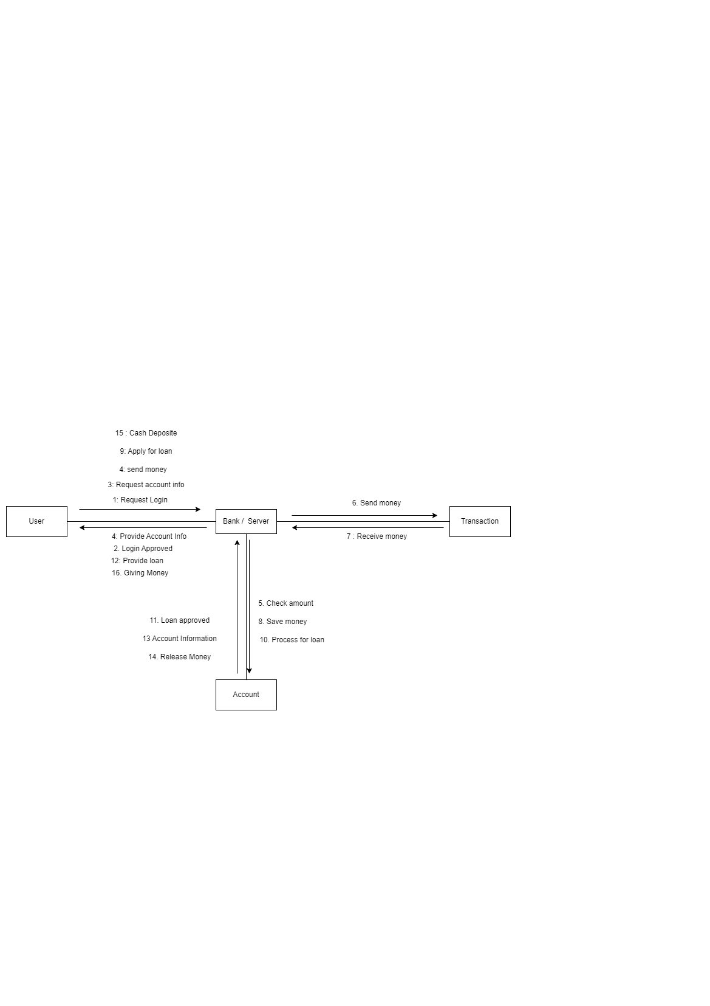**ACTIVITY/OBSERVATION**